Unit:
Steps of the Method

Glue this side down into your ISN using only
4 dots of glue

“A dot is a lot!”

What is the Scientific Method?

Quantitative Data | Qualitative Data
Example | Example

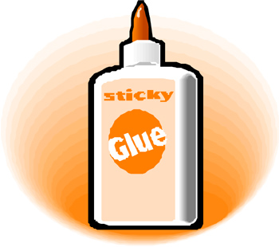

Why must experiments be controlled?

Independent Variable | Dependent Variable
Example: | Example:
Control Group | Experimental Group
Example: | Example:

Law | Theory
Constants

What are the differences between
Theory and Law?

