Use your knowledge of Mendelian genetics to complete this worksheet

What is Gerdy’s

genotype? _____

b) SpongeBillyBob is heterozygous for his squarepants shape. What is his genotype? __________________________

c) Complete the Punnett square to show the possibilities if BillyBob and Gerdy had children

d) What is the probability of kids with square pants? ______ %

e) What is the probability of kids with roundpants? _________ %

5. SongeBob’s aunt is famous around town for her itty, bitty stubby nose. She recently met a cute squarepants fellow who also has a stubby nose, which is a recessive trait. Would it be possible for them to have a child with a regular nose? Why or why not? Use a Punnett square to help answer the question.

Glue this side down into your ISN using only

**4** dots of glue

**“A dot is a lot!”**

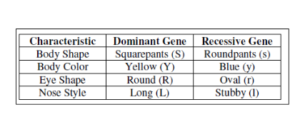

1. Use the information for SpongeBob’s traits to write the phenotype for each item

a) LL - ___________ b) yy – ___________

c) Ss – ___________ d) RR - ___________

e) Rr - ___________ f) ll - ___________

g) ss - ___________ h) Yy - ___________

2. Use the information in the chart above to write the genotype(s) for each trait.

a) yellow body - ____ b) roundpants - ____

c) oval eyes - ____ d) long nose - ____

e) stubby nose - ____ f) round eyes - ____

g) squarepants - ____ h) blue body - ____

3. Determine the genotypes for each trait using the above chart.

a) heterozygous round eyes - ____

b) purebred squarepants - ____

c) homozygous long nose - ____

d) hybrid yellow body - ____

4. One of SponeBob’s cousins, SpongeBillyBob, recently met a cute squarepants gal, SpongeGerdy, at a local dance and fell in love. Use your knowledge of genetics and. the above chart to answer the following questions.

a) If SpongeGerdy’s father is heterozygous squarepants and her mother is a roundpants, what is Gerdy’s genotype? Complete the Punnett square below to help you determine Gerdy’s genotype.

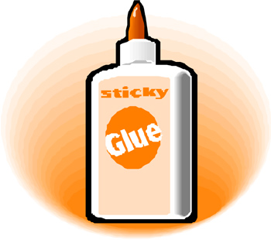

8) Determine the phenotype for each genotype

Yellow body is color is dominant to blue

YY ________ Yy _________ yy ________

Square shape is dominant to round

SS ________ Ss _________ ss ________

9) Determine the genotype(s) for each phenotype

Tall head (T) is dominant to short (t)

Tall = __________ Short = _________

Pink body (P) is dominant to yellow body (p)

Pink = __________ Yellow = _________

9) SpongeBob Squarepants recently met SpongeSusie Roundpants at a dance. SpongeBob is heterozygous for his square shape, but Susie is round. Create a Punnett square to show the possibilities that would result if they had little ‘sponges’.

a) List ALL possible

genotypes and phenotypes

for the offspring

b) What are the chances of a child with square shape? ____ out of ____ or ____ %

c) What are the chances of a child with round shape? ____ out of ____ or ____ %

10) Patrick met a gal, Patti, at the dance. Both of them are heterozygous for their pink body color.

a) List ALL possible genotypes and phenotypes for

the offspring

6. SpongeBob’s aunt and uncle, SpongeWilma and SpongeWilbur, have the biggest round eyes in the family. Wilma is believed to be heterozygous for her round eye shape, while Wilbur’s family brags that they are a pure line.

a) Give the genotypes for each ‘person’

Wilma - _________ Wilbur - _________

b) Complete the Punnett square to show the possibilities that would result if they had children

d) List ALL possible

genotypes and

phenotypes for the

kids

e) What is the probability that the kids would have round eyes? ________ %

f) What is the probability that the kids would have oval eyes? _________ %

7) If SongeBob’s aunt (described in #5) wanted children with long noses, what type of fellow would she need to marry in order to give her the best chances? Create a Punnett square to help you find the “ideal” fellow.

b) What are the chances of a child with a pink body? ____ out of ____ or ____ %

c) What are the chances of a child with a yellow body? ____ out of ____ or ____ %

11) Everyone in Squidward’s family has light blue skin (B), which is dominant trait for body color in his home town of Squid Valley. His family brags that they are “purebreds”. He recently married a nice girl who has light skin green skin (b), which is a recessive trait.

a) Squidward and his new bride had little squids that ended up being light green skin. Can Squidward’s family still claim to be “purebreds”? Why or why not? Use a Punnett square to support your answer.

12) Mr. Krabb and his wife recently had a Lil’Krabby, but it has not been a happy occasion for them. Mrs. Krabb has been very upset since she first saw her new baby who had short eyeballs. She claims that the hospital goofed and mixed up her baby with someone else’s. Mr.Krabb is homozygous dominant for his tall eyeballs, while his wife is heterozygous. Some members of her family have short eyes (which is recessive). Did the hospital make a mistake? Use a Punnett square to explain your answer.