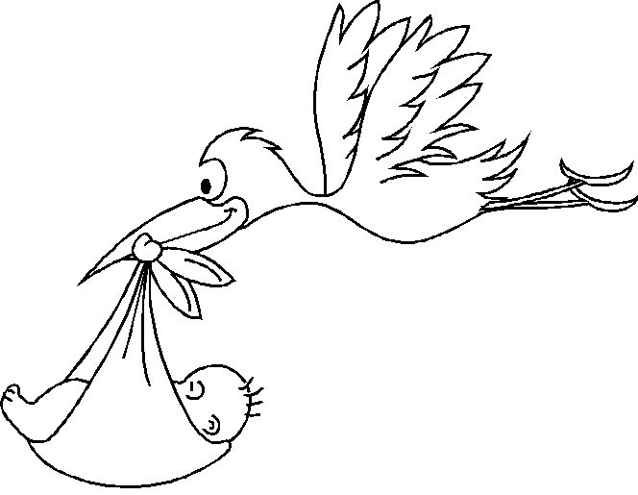Mother’s Information Father’s Information
NAME:___________________________________ NAME:________________________________
Date of Birth_____________________________ Date of Birth__________________________________

Choose Five Traits that you would like to see in your baby. The sixth chromosome is an X or a Y (sex chromosomes) and does not require an allele in the upper box.
Trait #1 _______________________________ Your Genotype _______ Trait #1 _______________________________ Your Genotype _______
Trait #2 _______________________________ Your Genotype _______ Trait #2 _______________________________ Your Genotype _______
Trait #3_______________________________ Your Genotype _______ Trait #3_______________________________ Your Genotype _______
Trait #4 _______________________________Your Genotype_______ Trait #4 _______________________________Your Genotype_______
Trait #5 _______________________________Your Genotype _______ Trait #5 _______________________________Your Genotype ______
Trait #6 _______________________________Your Genotype _______ Trait #6 _______________________________Your Genotype ______

State where the happy couple met. ____________________________________________________________________________________________________.

Baby’s Genotypes/Phenotypes

Trait #1 _______________________________ Baby Genotype _______ Baby’s Phenotype ____________________________________________
Trait #2 _______________________________ Baby Genotype _______ Baby’s Phenotype ____________________________________________
Trait #3_______________________________ Baby Genotype _______ Baby’s Phenotype ____________________________________________
Trait #4 _______________________________Baby Genotype_______ Baby’s Phenotype ____________________________________________
Trait #5 _______________________________Baby Genotype _______ Baby’s Phenotype ____________________________________________
Trait #6 _______________________________Baby Genotype _______ Baby’s Phenotype ____________________________________________
Sex Chromosomes Baby’s Sex Genotype_______ Baby’s Phenotype_____________________________________________

Name of Child_________________________________________________________________________________________________________________
Date of Birth _______________________________________________ Time of Birth:_______________________________________________
Weight ___________________ Length _____________________ Amount of time you labored on this child:________________________
Draw your child with his/her traits on the other side of this sheet. Be sure to fill the page with your baby’s features.

