Drop Your Genes – Observable Traits

You have over 50,000 observable traits. Here are a few which are easily observable. Use this page to help you do the activity which follows.
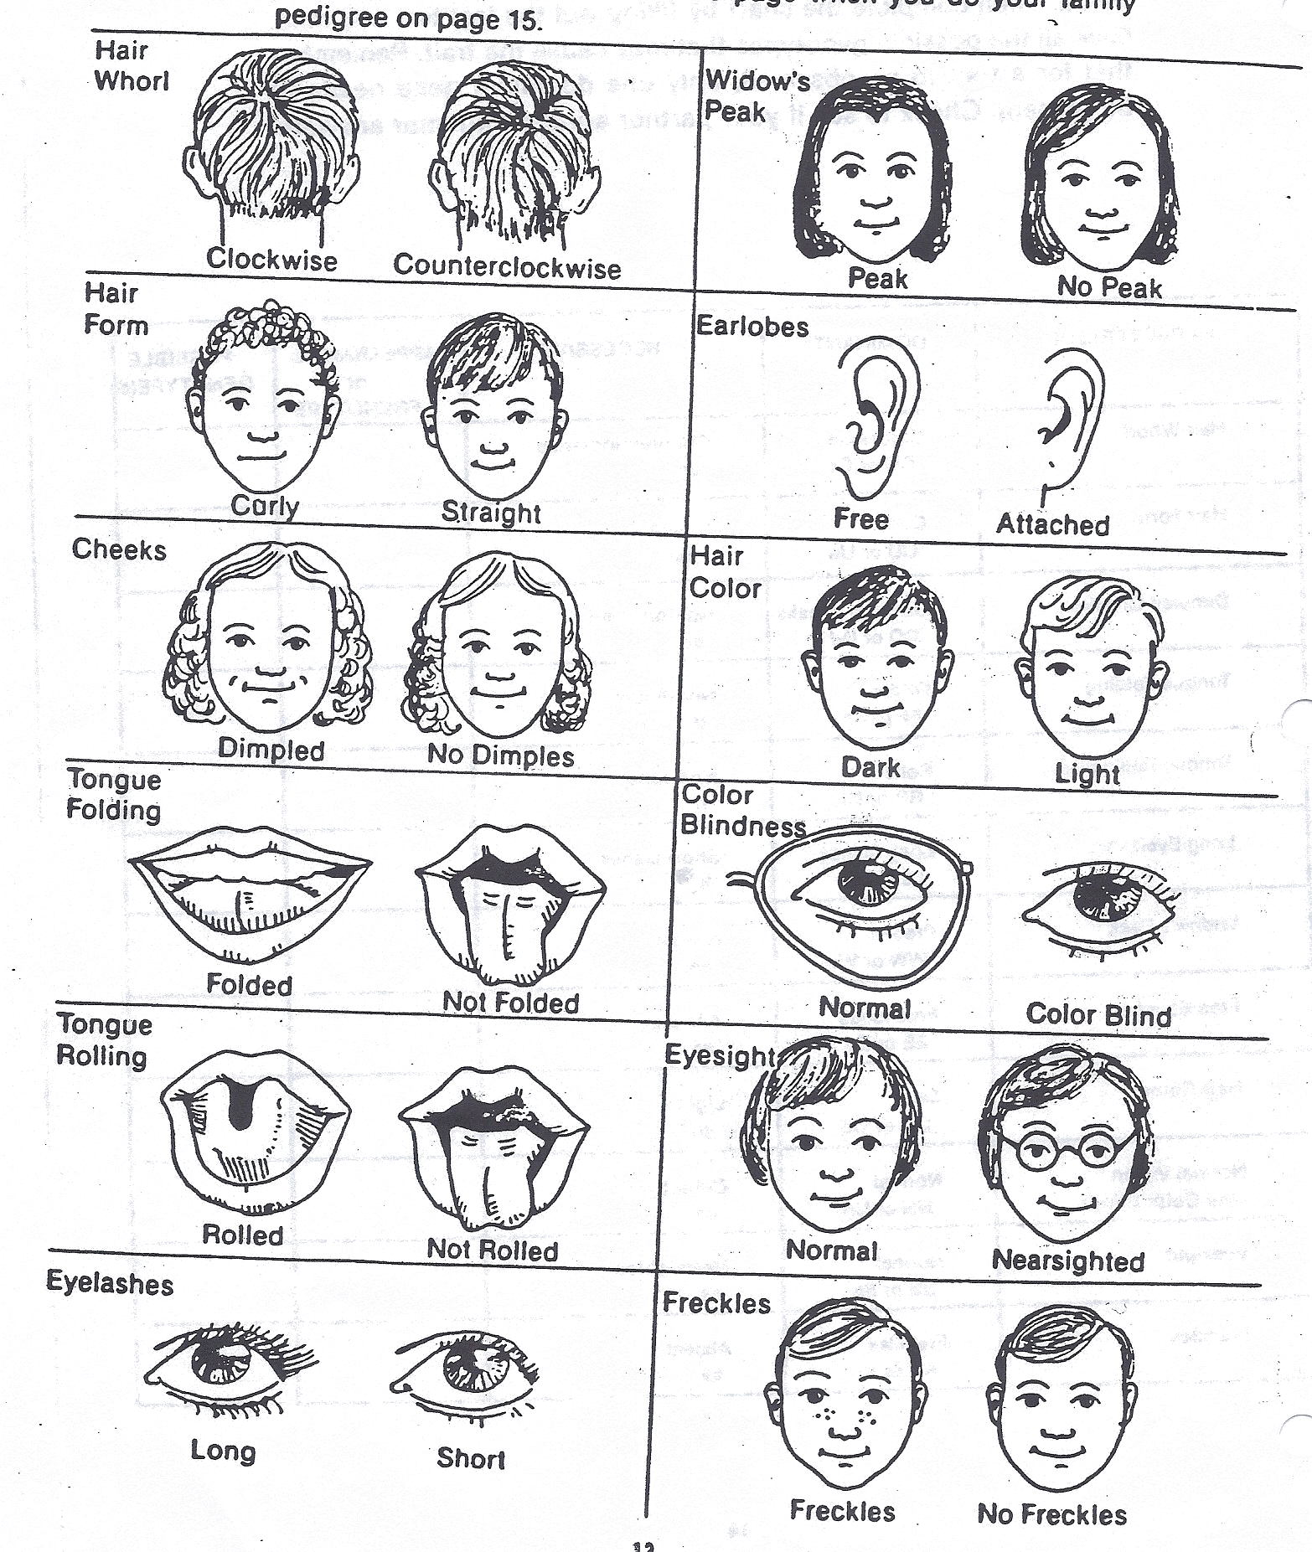
With a lab partner observe each other’s heredity traits as listed below. Then complete the chart by filing out the last two columns. Give all the possible genotypes observed that may cause the trait. Remember that for a trait to be observed; only one dominant gene needs to be present. Check to see if your partner agrees with your answers.
CHARATERISTIC | DOMINANT | RECESSIE | APPEARANCE or PHENOTYPE | POSSIBLE GENOTYPE(S)
Hair whorl | Clockwise CC or Cc | Counterclockwise cc
Hair form | Curly UU or Uu | Straight uu
Dimpled cheeks | Dimpled DD or Dd | Non-dimpled dd
Tongue folding | Folder FF or Ff | Non-folder ff
Tongue rolling | Roller RR or Rr | Non-roller rr
Eyelash length | Long lashes LL or Ll | Short lashes ll
Widow’s Peak | Present WW or Ww | Absent ww
Earlobe attachment | Free lobes EE or Ee | Attached ee
Hair color | Dark HH or Hh | Light hh
Color Vision | Normal NN or Nn | Color blind nn
Eyesight | Normal SS or Ss | Nearsighted ss
Freckles | Present KK or Kk | Absent kk

